**India’s Agricultural Crop Production Analysis(1197-2021)**

This report delves into the captivating realm of India's agricultural cultivation, providing a comprehensive visual exploration of key aspects and trends in the agricultural sector. Through the visual representations, readers can gain valuable insights into crop production, seasonal variations, regional distribution, and overall production trends. These visualizations enable intuitive analysis, allowing stakeholders to uncover patterns, identify areas of growth or concern, and make data-driven decisions.

By harnessing the power of Tableau, this report not only presents the data in a visually appealing manner but also provides an interactive experience for readers to explore the intricacies of India's agricultural cultivation. To Extract the Insights from the data and put the data in the form of visualizations, Dashboards and Story we employed Tableau tool.

**Technical Architecture:**

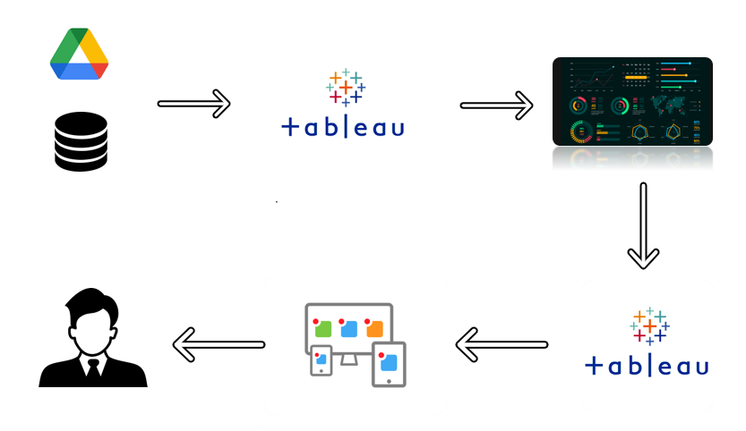

**Project Flow**

To accomplish this, we have to complete all the activities listed below,

* Define Problem / Problem Understanding
  + Specify the business problem
  + Business requirements
  + Literature Survey
  + Social or Business Impact.
* Data Collection & Extraction from Database
  + Collect the dataset,
  + Storing Data in DB
  + Perform SQL Operations
  + Connect DB with Tableau
* Data Preparation
  + Prepare the Data for Visualization
* Data Visualizations
  + No of Unique Visualizations
* Dashboard
  + Responsive and Design of Dashboard
* Story
  + No of Scenes of Story
* Performance Testing
  + Amount of Data Rendered to DB ‘
  + Utilization of Data Filters
  + No of Calculation Fields
  + No of Visualizations/ Graphs
* Web Integration
  + Dashboard and Story embed with UI With Flask
* Project Demonstration & Documentation
  + Record explanation Video for project end to end solution
  + Project Documentation-Step by step project development procedure

**Milestone 1: Define Problem / Problem Understanding**

**Activity 1: Specify the business problem**

Refer Project Description

**Activity 2: Business requirements**

The primary business requirements for this report are to visualize and analyze business expenses, provide industry-specific insights, identify cost drivers, highlight outliers, and offer interactive functionality. Stakeholders need a visual representation of expenses to compare and analyze spending patterns across different businesses and industries. The report should facilitate the identification of key cost drivers, enabling stakeholders to understand the primary factors contributing to expenses. Additionally, it should flag any outliers or anomalies for further investigation. The report should provide a user-friendly and intuitive experience that empowers stakeholders to make data-driven decisions and drive positive change in the agricultural sector.

**Activity 3: Literature Survey**

The literature survey section of the report provides a concise overview of India's agricultural sector, focusing on key aspects and insights from existing studies and publications. It examines the historical context of agricultural practices in India and highlights the role of government policies and initiatives in supporting the sector's growth and development.

The survey explores the diversity of crops cultivated across different regions, along with trends in production and the impact of climate variability. It also addresses the adoption of technology and innovation in agriculture, along with the challenges faced by farmers and potential research gaps.

Additionally, the section showcases best practices and success stories that have contributed to improved productivity and sustainability in Indian agriculture. This literature review forms the basis for the subsequent analysis and visualization of agricultural data in the report.

**Activity 4: Social or Business Impact.**

Social Impact: On the social front, agriculture serves as a vital source of livelihood for a large portion of the population, especially in rural areas. It plays a crucial role in ensuring food security and alleviating poverty by providing employment opportunities and income generation. Moreover, agricultural activities contribute to the overall socio-economic development of rural communities, fostering social cohesion and preserving cultural traditions.

Business Impact: From a business perspective, the agricultural sector plays a pivotal role in India's economy. It contributes to the country's GDP and serves as a source of raw materials for various industries, such as food processing, textile, and pharmaceuticals. The growth and productivity of the agricultural sector have direct implications for the overall economic performance and stability of the nation. Furthermore, advancements in agricultural practices and technology have the potential to enhance productivity, optimize resource utilization, and promote sustainable practices. This, in turn, can lead to increased profitability and competitiveness for agricultural businesses.

**Milestone 2: Data Collection & Extraction from Database**

Data collection is the process of gathering and measuring information on variables of interest, in an established systematic fashion that enables one to answer stated research questions, test hypotheses, evaluate outcomes and generate insights from the data.

**Activity 1: Downloading the dataset**

Please follow link to download:

<https://www.kaggle.com/datasets/pyatakov/india-agriculture-crop-production>

**Activity 1.1: Understand the data**

Data consists of 345409 rows and 10 columns that correspond to different values.

**Column Description of the Dataset:**

State : The name of the Indian states.

District : The name of the districts of Indian states.

Crop : Name of different crops grown in India

Year : Date

Season : India has 5 seasons for crop cultivation kharif, rabi, autumn, winter and summer.

Area: Area for crop cultivation in acres

Production : Production of crops in tonnes

Yield : Yield by the crops under cultivation

**Activity 2: Storing Data in DB & Perform SQL Operations**

Explanation video link:

<https://drive.google.com/file/d/1Q7ywnjxIR4HPOTagRMGqxpCvgAEvLZ-y/view?usp=sharing>

**Activity 3: Connect DB with Tableau**

Explanation video link:

<https://drive.google.com/file/d/1Q7ywnjxIR4HPOTagRMGqxpCvgAEvLZ-y/view?usp=sharing>

**Milestone 3: Data Preparation**

**Activity 1: Prepare the Data for Visualization**

Preparing the data for visualization involves cleaning the data to remove irrelevant or missing data, transforming the data into a format that can be easily visualized, exploring the data to identify patterns and trends, filtering the data to focus on specific subsets of data, preparing the data for visualization software, and ensuring the data is accurate and complete. This process helps to make the data easily understandable and ready for creating visualizations to gain insights into the performance and efficiency.

<https://drive.google.com/drive/folders/1pGP1zAVkHZFPWK4iy8IYOSf2HIOM2hXS?usp=sharing>

**Milestone 4: Data Visualization**

Data visualization is the process of creating graphical representations of data to help people understand and explore the information. The goal of data visualization is to make complex data sets more accessible, intuitive, and easier to interpret. By using visual elements such as charts, graphs, and maps, data visualizations can help people quickly identify patterns, trends, and outliers in the data.

**Activity 1: No of Unique Visualizations**

The number of unique visualizations that can be created with a given dataset. Some common types of visualizations that can be used to analyse the performance and efficiency of banks include bar charts, line charts, heat maps, scatter plots, pie charts, Maps etc.

**Activity 1.1 : State wise Agricultural Land Pie Chart**

Explanation video link:

<https://drive.google.com/file/d/1PaSLGrVtJ0iSMWK41FChR5aQUeOXF_Xa/view?usp=sharing>

**Activity 1.2 : Top Large area sets**

Explanation video link:

<https://drive.google.com/file/d/1SvwXILi_5K_Sa-z1xZLiycRk7pWS4R24/view?usp=sharing>

**Activity 1.3 : Crop year vs Production Year**

Explanation video link:

<https://drive.google.com/file/d/1Tzcu-yLYg7hGcAUMa13Z3tZ-cV8bl9WS/view?usp=sharing>

**Activity 1.4 : High Crop Production**

Explanation video link:

<https://drive.google.com/file/d/1-yJzYh1xguobASYbfNjZbv8Gfie4jXg0/view?usp=sharing>

**Activity 1.5 : Crop plantation by area**

Explanation video link:

<https://drive.google.com/file/d/11UYnJDPoN_6gPyKt3L7YiKs-sHKhCuPj/view?usp=sharing>

**Activity 1.6 : Major crops Map Visualizing**

Explanation video link:

<https://drive.google.com/file/d/1RDkFu7ce_1FfPAM0dUmsa5I74HkK-l_A/view?usp=sharing>

**Activity 1.7 : Crops Area**

Explanation video link:

<https://drive.google.com/file/d/1VHM9bmbHAIa013UpsbjnEBkdb1pjV8ao/view?usp=sharing>

**Activity 1.8 : Season wise production**

Explanation video link:

[https://drive.google.com/file/d/1-](https://drive.google.com/file/d/1- dmcweuRewNYGdxpxnTQ4oqaeThY5NWN/view?usp=sharing)

[dmcweuRewNYGdxpxnTQ4oqaeThY5NWN/view?usp=sharing](https://drive.google.com/file/d/1- dmcweuRewNYGdxpxnTQ4oqaeThY5NWN/view?usp=sharing)

**Milestone 5: Dashboard**

A dashboard is a graphical user interface (GUI) that displays information and data in an organized, easy-to-read format. Dashboards are often used to provide real-time monitoring and analysis of data and are typically designed for a specific purpose or use case. Dashboards can be used in a variety of settings, such as business, finance, manufacturing, healthcare, and many other industries. They can be used to track key performance indicators (KPIs), monitor performance metrics, and display data in the form of charts, graphs, and tables.

**Activity 1: Responsive and Design of dashboard**

Once you have created views on different sheets in Tableau, you can pull them into a dashboard.

**Activity 1.1 : Dashboard**

Explanation video link:

<https://drive.google.com/file/d/1be2bOfW-pLJLhaQV6Dcwi5RluVMbHKNo/view?usp=sharing>

**Milestone 6: Story**

A data story is a way of presenting data and analysis in a narrative format, intending to make the information more engaging and easier to understand. A data story typically includes a clear introduction that sets the stage and explains the context for the data, a body that presents the data and analysis logically and systematically, and a conclusion that summarizes the key findings and highlights their implications. Data stories can be told using a variety of mediums, such as reports, presentations, interactive visualizations, and videos.

**Activity 1: Number of scenes in a story**

The number of scenes in a storyboard for a data visualization analysis of the performance of banks will depend on the complexity of the analysis and the specific insights that are trying to be conveyed. A storyboard is a visual representation of the data analysis process and it breaks down the analysis into a series of steps or scenes.

**Activity 1.1 : Story 1**

Explanation video link:

<https://drive.google.com/file/d/1mvCmzk5qMvI9sicPqJEzLHV0RUGUBOIX/view?usp=sharing>

**Milestone 7: Performance Testing**

**Activity 1: Amount of Data Rendered to DB**

* The amount of data that is rendered to a database depends on the size of the dataset and the capacity of the database to store and retrieve data.
* Open the MySQL Workbench, go to the database then click to expand the tables,select the table and click on (i) button to get the information related to table such as column count,table rows etc.

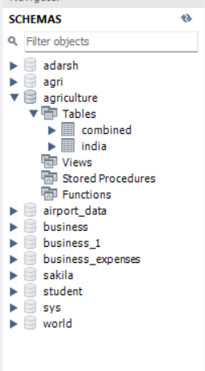

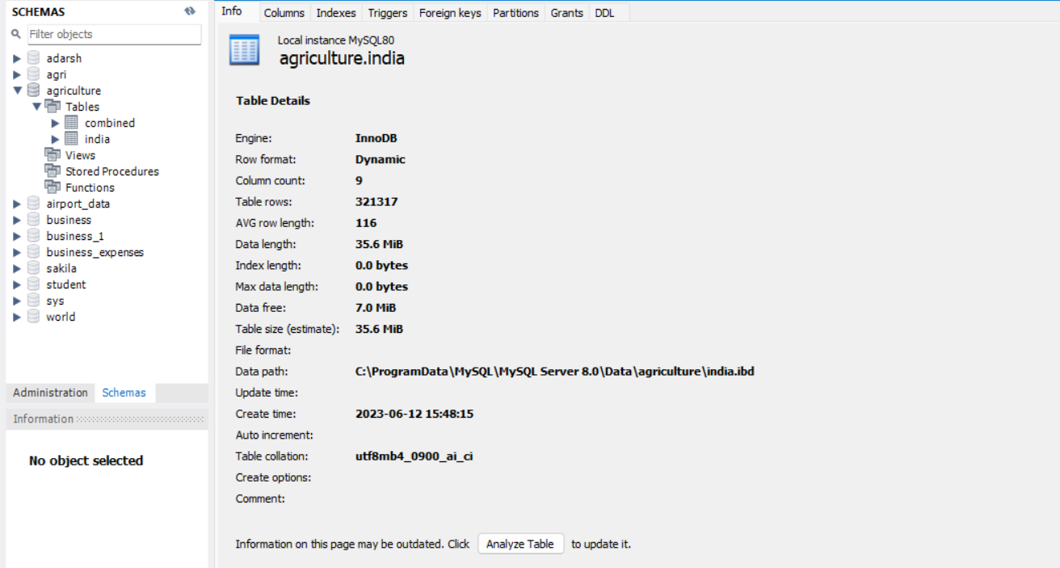

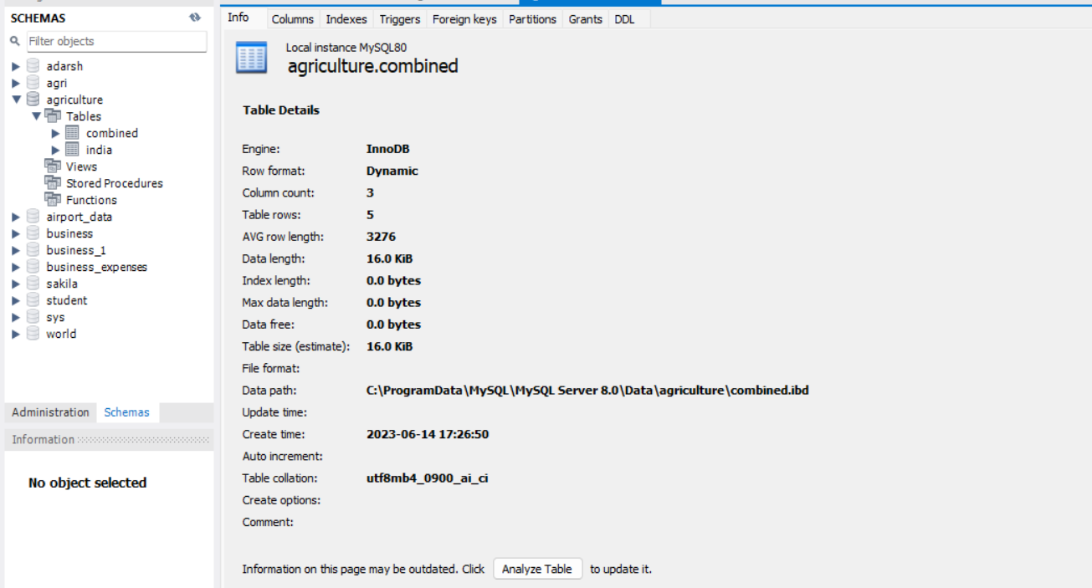

**Activity 2: Number of calculation fields**

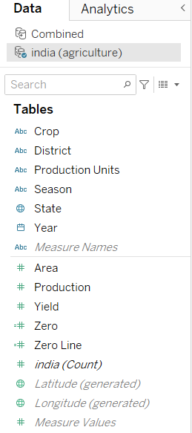

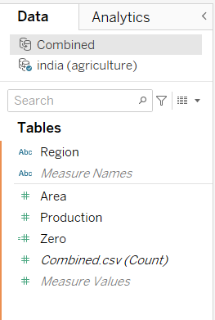

**Activity 3: Number of visualizations**

1. State wise Agricultural Land Pie Chart
2. Top Large area sets
3. Crop year vs production year
4. High Crop production
5. Crop plantation by area
6. Major crops Map Visualizing
7. Crops Area
8. Season wise production

**Milestone 8: Web integration**

Publishing helps us to track and monitor key performance metrics and tommunicate results and progress. help a publisher stay informed, make better decisions, and communicate their performance to others.

**Activity 1: Publishing dashboard and reports to tableau public**

Explanation video link:

<https://drive.google.com/file/d/1cRl1bedHnSNtKPzyL_1LODCuaLptKjDE/view?usp=sharing>

**Activity 2: Embed dashboard and story with bootstrap**

Explanation video link:

<https://drive.google.com/drive/folders/1cUxaDhQoSVpziOesll6-3T3s2d5ppLbv?usp=sharing>

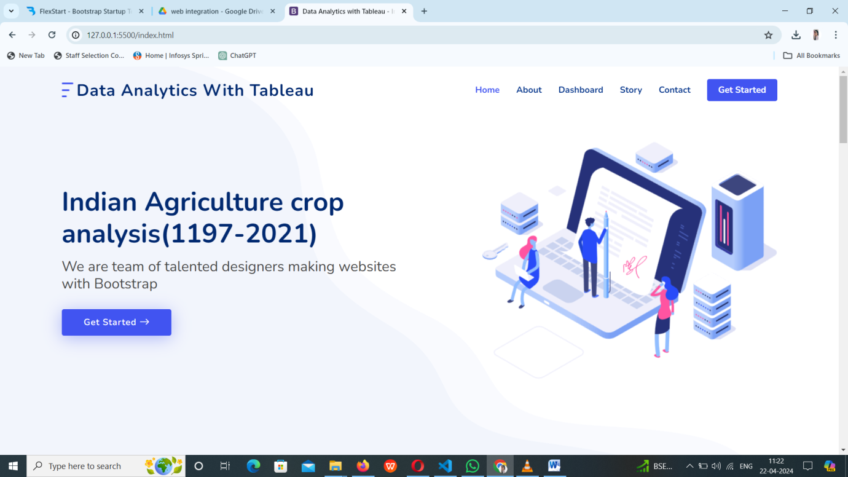

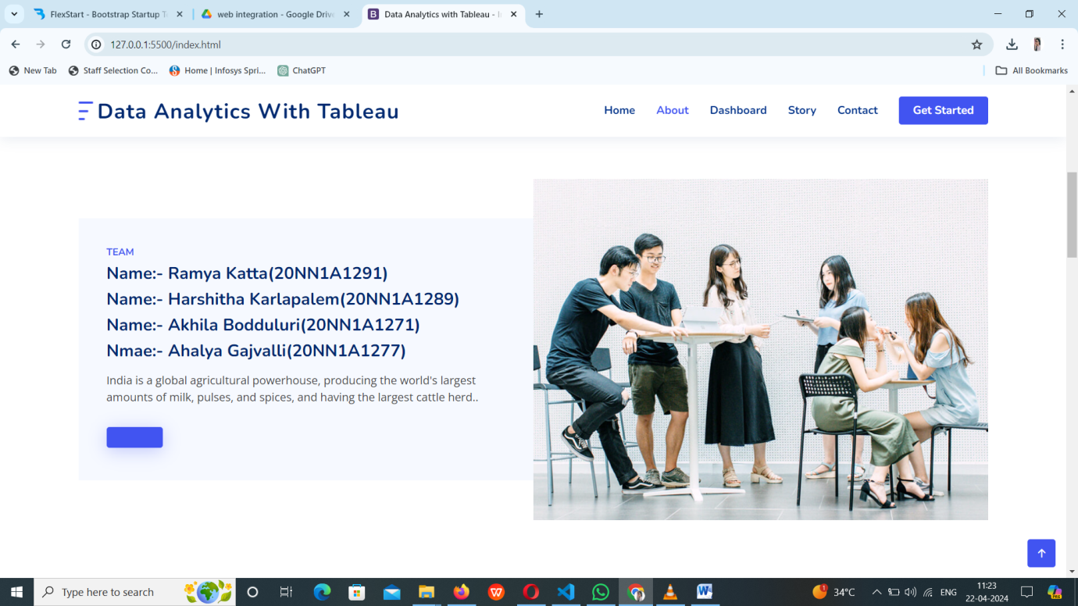

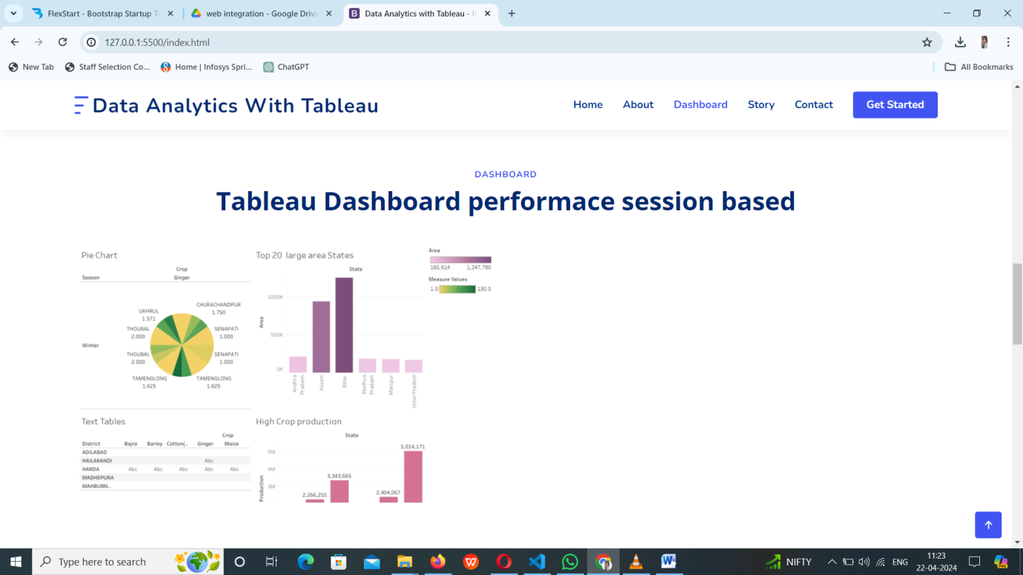

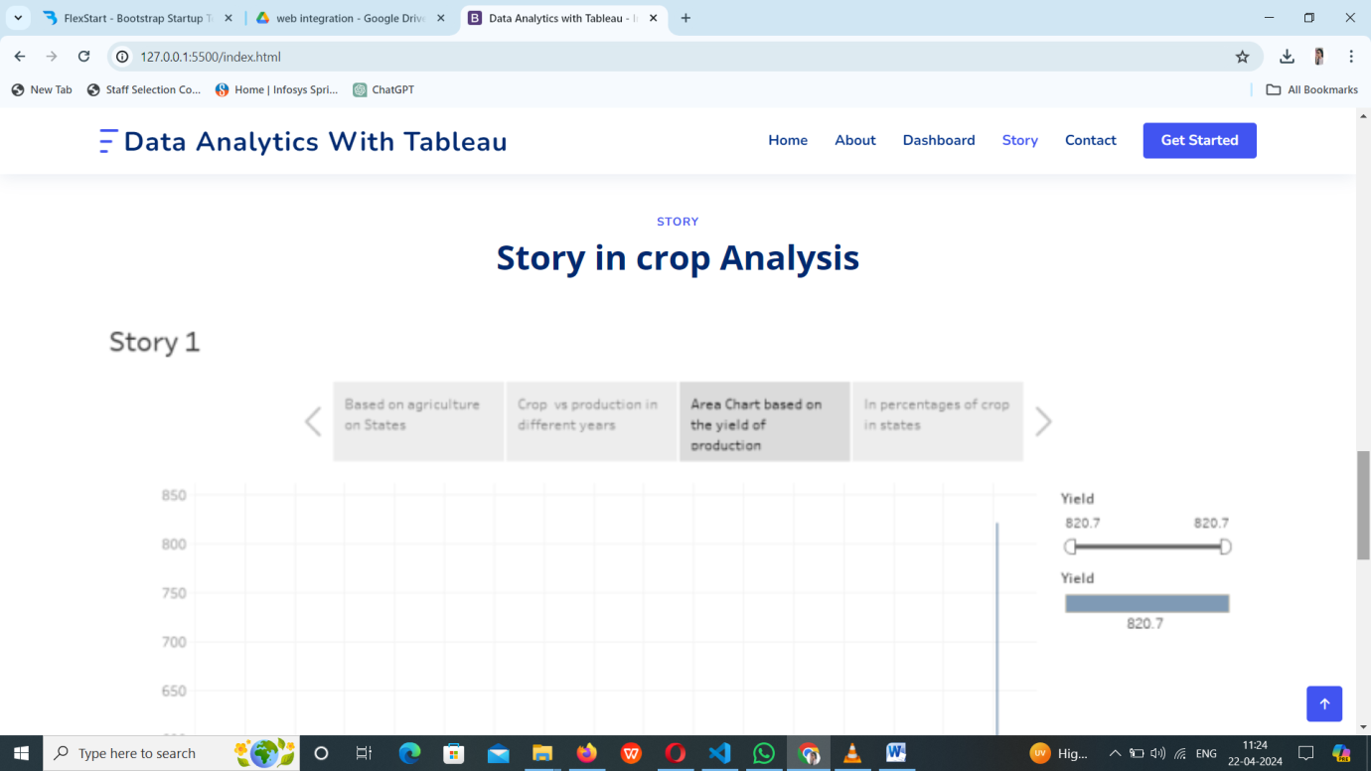

Flask Template Code run:-

